1. Biscet model there is 3 function that may use for binary search to find the position where we can add element in sorted list or position sorted element in list with maintained of the list sorted.(similar like upper_bound and lower_bound in cpp)

Functions name: bisect (lst, num, beg, end), bisect_left(list, num, beg, end) , Biscet_right(list, num, beg, end)

Link: <https://www.geeksforgeeks.org/bisect-algorithm-functions-in-python/>

1. To find the max in dictionary :

Tpl = max(zip(dict.values(), dict.keys())

Give tuple of key and value

Link: <https://www.geeksforgeeks.org/python-get-key-with-maximum-value-in-dictionary/>

1. Fun np.where() fun return the index where condition inside () is meet

Link: <https://www.geeksforgeeks.org/numpy-where-in-python/\>

**import** numpy **as** np

arr **=** np**.**arange(1,11)

arr[arr **%** 2 **!=** 0] **=** **-**1

print(**\***arr)

in this code all odd values places replaced with -1

1. **SyntaxError:** (unicode error) 'unicodeescape' codec can't decode bytes in position 2-3: truncated \UXXXXXXXX escape

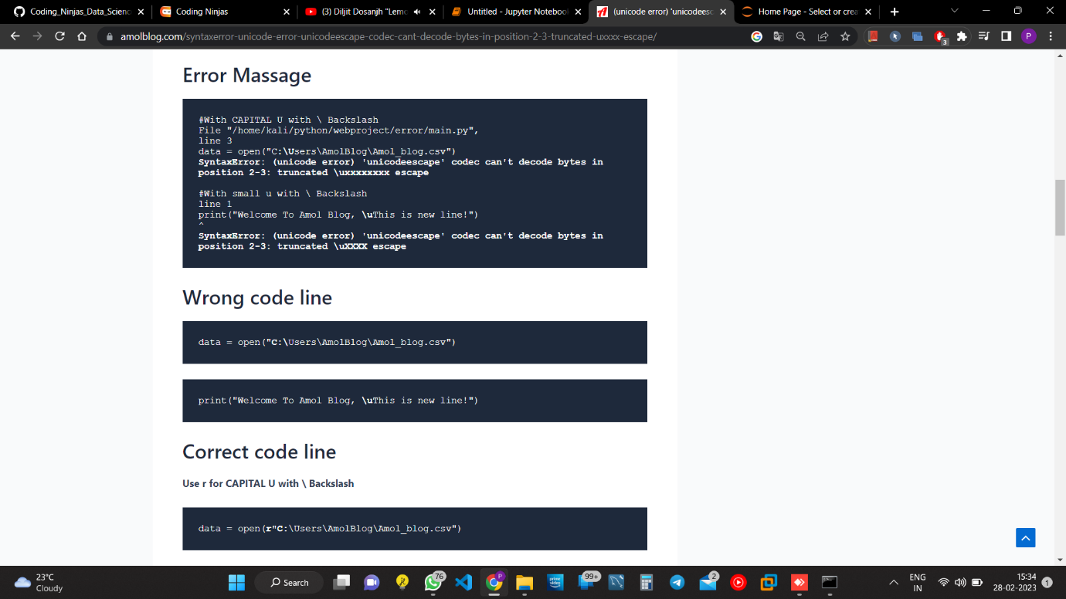

1. Python Pandas group by function

<https://www.geeksforgeeks.org/python-pandas-dataframe-groupby/>

1. When we create the any constructor of the class by __intit__(self)

Here we have to pass at least one argument that refer to that class to itself but it mean not that self self (word) is compulsory mean we can use any other name on self. See the code

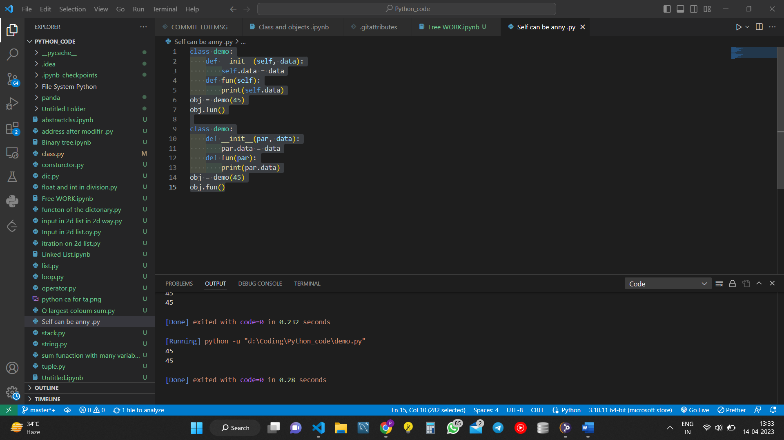

1. Difference between instance attribute and class attribute.

<https://www.codingninjas.com/codestudio/guided-paths/basics-of-python/content/118797/offering/1403021>

So class attribute are that same for all class instance and instance attribute are that as specific value for that instance.

1. MRO function

Link: <https://www.codingninjas.com/codestudio/guided-paths/basics-of-python/content/118797/offering/1404434>

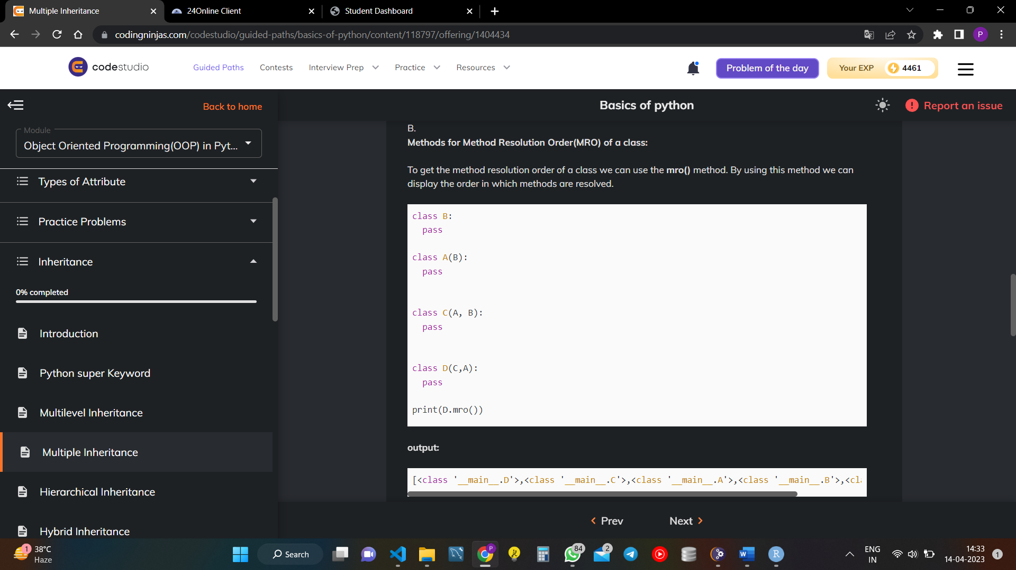

1. Try to understand the real- life use of the Type of inheritance.